

**NETWORKING & SYSTEM ADMINISTRATION LAB**

**Experiment No.: 3**

**Aim**

Familiarization of the linux commands.

**Procedure**

1. pwd

This command is used to display the location of the current working directory.

Syntax :- $ pwd

Output :-



2. mkdir

This command is used to create a new directory under any directory.

Syntax :- $ mkdir <directory name>

Output :-



3. ls

This command is used to display a list of content of directory.

Syntax :- $ ls

Output :-



4. man

This command is used to display the user manual of any command that we can run

on the terminal.

Syntax :- $ man <command name>

Output :-



5. ls –l

This command is used to shows file or directory, size, modified date and time, file

or folder name and owner of the file, and its permission.

Syntax :- $ ls –l

Output:-

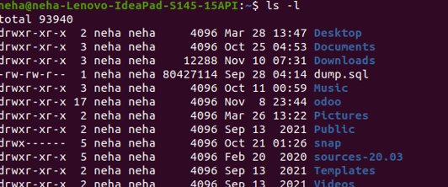

6. ls –r

This command is used to display files and directories in reverse order.

Syntax :- $ls –r

Output :-



7. ls –a

This command is used to list all files including hidden files.

Syntax :- $ls –a

Output :-



8. ls –al

List all the files including hidden files in the current directory

Syntax :- $ ls -al

Output :-

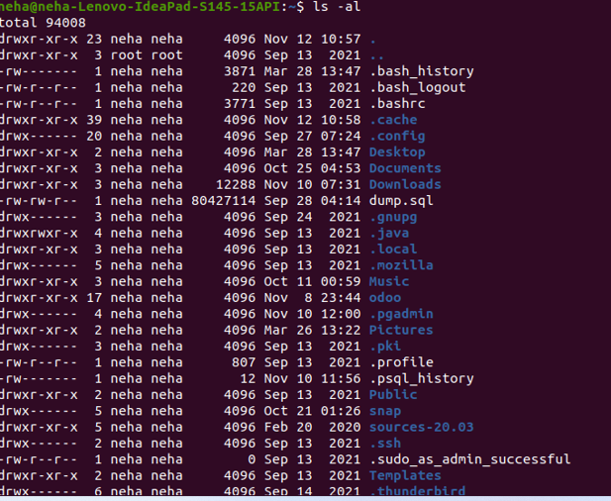

9. ls –t

This command is used to display files in the last modified order.

Syntax :- $ ls –t

Output :-



10. cd

This command is used to change the current directory.

Syntax :- $ cd <directory name>

Output :-



11. cd ..

This command is used to move to the parent directory of current directory, or the

directory one level up from the current directory.

Syntax :- $ cd ..

Output :-  


12. cd –

This command is used to switch back to previous directory we were working

earlier.

Syntax :- $ cd –

Output :-



13. cat > filename

This command is used to create a file and add contents to that file.

Syntax :- $ cat > filename.txt

Output :-

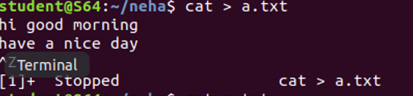

14. cat>>filename

This command is used to add contents to an existing file.

Syntax :- $ cat >> filename.txt

Output :-

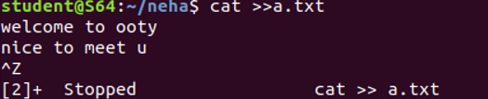

15. cat filename

This command is used to view the contents in the file.

Syntax :- $ cat filename.txt

Output :-

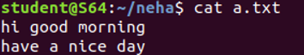

16. cat filename1 > filename2

This command is used to copy the content from one file to another file.

Syntax :- $ cat filename1 > filename2

Output :-

